Oakenhall Medical Practice Health Questionnaire

Full Name and Date of Birth
Marital Status | Single/Married/Widow
Address  Postal Code  Telephone Number  (I give my consent for the practice to contact me by SMS messaging) | YES / NO
Occupation (if employed)
Height Weight
Please Circle or detail which best describes your ethnic origins: | British White/Irish White/Any other white background  White & Black Caribbean/White & Black African/White &  Asian/Any other mixed background  Indian/Pakistani/Bangladeshi/Any other Asian background  Caribbean/African/Any other Black Background  Chinese/Any other ethnic Group Decline to give details
Please circle or detail your first language you mainly speak (i.e. the language in which you are most fluent | English/British Signing  Language/French/German/Italian/Japanese/Makaton (Sign  Language)/Polish/Russian/Spanish/Turkish/Other
Do You have any Information or Support Needs Such as: Large Print, hearing or visual loss, Braille, Easy Read, British Sign Language Interpreter etc. Information is available at
www.england.nhs.uk/accessibleinfo
Name of School Child Attends (For  Children in full time education)  Name of Child’s Primary Carer | Mother/Father/Foster Carer
Please list any current/past medical problems and any allergies

Please list any medications or tablets that you are currently taking

All prescriptions are now sent electronically to a nominated pharmacy. Please tick the pharmacy you wish to nominate  (If you prefer to use an online pharmacy, please contact them direct to inform them of your registered GP Practice) | □ Boots Pharmacy, 52-54 High Street, Hucknall  □ Harts Chemist, 106-110 Watnall Road, Hucknall  □ Lloyds Pharmacy, Farleys Lane, Hucknall  □ Manns Pharmacy, 13-15 Portland Road, Hucknall  □ Nabbs Lane Pharmacy, 63 Nabbs Lane, Hucknall  □ Tesco-In-Store Pharmacy, Ashgate Road, Hucknall  □ Other – please specify name and address
Do you have any medical conditions in the family? E.g. Diabetes, epilepsy, heart trouble, asthma, respiratory conditions, social or mental problems, hay fever, eczema or psoriasis?
Are you a Carer or do you care for anyone with a significant Physical or Mental Illness?
For Women Only
Are you using birth control now? If so which form of birth control are you using?
When was your last smear test?
How often do you exercise?  What form of exercise do you do? | Never/occasionally/How many days a week? – 1/2/3/4/5/6/7
Do you smoke?  If smoker – do you smoke?  How often do you smoke? | Never/Ex-smoker/Smoker  Cigarettes/Cigar/Pipe  Per Day …………………………………. Per Week ………………………..

This is one unit of alcohol…
…and each of these is more than one unit
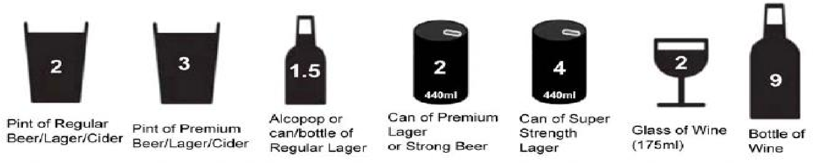
Questions |  | Scoring system |  |  |  | Your score
 | 0 | 1 | 2 | 3 | 4
How often do you have a drink containing alcohol? | Never | Monthly or less | 2 - 4 times per month | 2 - 3 times per week | 4+ times per week
How many standard alcoholic drinks do you have on a typical day when you are drinking? | 1 -2 | 3 - 4 | 5 - 6 | 7 - 9 | 10+
How often do you have 6 or more standard drinks on one occasion? | Never | Less than monthly | Monthly | Weekly | Daily or  almost daily
Scoring:
Your Total:

If your overall total score is 5 or above please arrange appointment with the Practice Nurse.

EMERGENCY SUMMARY CARE RECORD -The NHS in England has introduced the Summary Care Record, which will be used in emergency care. The record will contain information about any medicines you are taking, allergies you suffer from and any bad reactions to medicines you have had, to ensure those caring for you have enough information to treat you safely. As a patient you have a choice:

□ Yes I would like a Summary Care Record – Healthcare staff will ask you permission before they look at your record, except in certain circumstances for example if you are unconscious.

□ No I do not want a Summary Care Record – Please ask Reception Staff for the opt out form

SHARING YOUR DETAILED CARE RECORD - Your care record contains medical information recorded by health workers who have been involved in your care. This information could include: letters from the hospital, information about your visits, test results, medications, allergies and diagnoses. Information may have been added to your record at many different care locations. Sharing your record means that health workers will have your most up to date information. Detailed care record sharing is different from national sharing schemes such as the Summary Care Record and care data as these do not share the full record. To improve their care some patients may have their detailed care record shared automatically e.g. children 15 years and under. A patient information leaflet is available by request at the main reception. Further information is available at www.nhs.uk/caredata or by viewing an explanatory video on https://vimeo.com/124915322.

I understand that the same record is used to store information recorded by different members of the care teams who are currently involved in providing my care, including but not limited to doctors surgeries, district nurses, health visitors, physiotherapists, podiatrists, social care and child health. I understand that I will be asked to give consent by each care team before they are able to access or add to any shared data about me.

Share-out
I would* / would-not* like the information recorded at Oakenhall Medical Practice to be available to be seen by other care teams who are involved in my care where I have granted those care teams access to see my shared data.

Share-in
I would* / would-not* like the information recorded at other care teams who are involved in my care to be seen by members of the team at Oakenhall Medical Practice, where I have granted those care teams the right to add to my shared data.

* Delete as appropriate

I understand that I can change my decision at any time.
Patient Name | Patient’s Signature | Date
Or
Patients Representative’s Name: | Patients Representative’s Signature | Relationship to Patient

Online access to digital records
We offer online access to your digital record. If you would like to register for this service, please visit our website to download an application form. http://www.oakenhallmedicalpractice.co.uk/online-services

We also offer full online access to your digital record for prospective information, starting from the date of your request.

An alternative online access to you digital records is available through the NHS APP – if you would like to register for this services please visit: https://www.nhs.uk/nhs-app/

Oakenhall Medical Practice
Approval Date: 9/6/22
Review Date: 9/6/23

